**Target audience:**

The target audience of my informational site is daredevils who want to go skydiving. Skydiving customers range in age but tend to be male and female young adults. Skydiving is not a cheap endeavor. It typically costs $200-400 to go skydiving based on the format of the skydive (tandem or solo, type of video package) so customers tend to come from wealthy backgrounds.

**Why are people visiting your site?**

Potential skydiving customers will visit my site to learn more about skydiving through text and visuals (photos and videos). My website will inform its viewers about the skydiving experience and how it feels to jump out of an airplane.

**Content:**

The content on my website will include the following videos, photos, and text/articles.

Videos:

<https://www.youtube.com/watch?v=yeeIB47sICg>

<https://www.youtube.com/watch?v=CzZRu2MLgxk>

<https://www.youtube.com/watch?v=aMORCTNPzy0>

Photos:

<https://www.skydiveorange.com/2018/06/05/how-much-does-it-cost-to-go-skydiving-in-virginia/>

<https://www.skydiveatlanta.com/tandem-skydiving-atlanta-georgia/>

<https://skyventurenh.com/what-i-really-think-about-skydiving/>

Text/Articles:

<https://www.skydivecsc.com/blog/what-does-skydiving-feel-like>

<https://www.skydivedanielson.com/what-does-it-feel-like-to-skydive/>

<https://skydivemonroe.com/blog/what-does-it-feel-like-first-time-skydiving/>

**Wireframe:**

See attached photo.

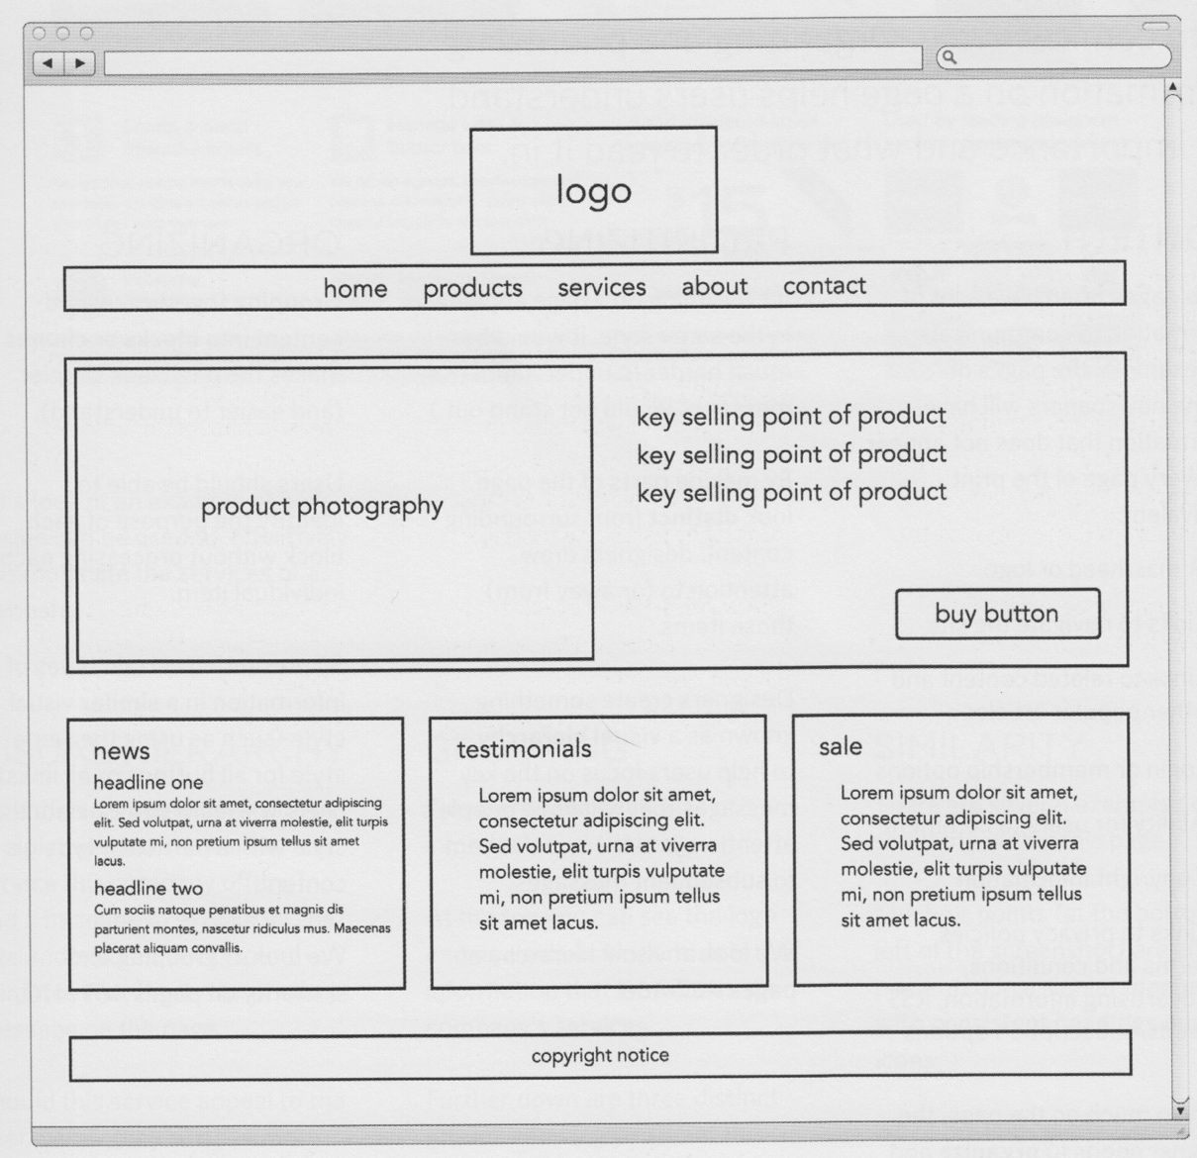

**Technical requirements:**

Use one of the following:

Bootstrap

Grid-view, <https://www.w3schools.com/css/css_rwd_grid.asp>

The site must have a link on your default page (index.html).

At least three web pages.

Consistent style from page to page.

Persistent navigation.

Contain text and images.

Multiple elements on the home page where you can demonstrate various techniques. I will approve your wireframe.